**CSCI251 Assignment 2 Documentation**

Created On (25/01/2025)

Student Name: Ooi Jun Kang

Student No: 9071180



**Introduction**

For this assignment, I am tasked to make a shape2D program that can take in a number of coordinates depending on the shape and if the user wants to defined as a WS(Warp-space) or NS(Normal-space) into the array, for example square, rectangle, circle and cross.

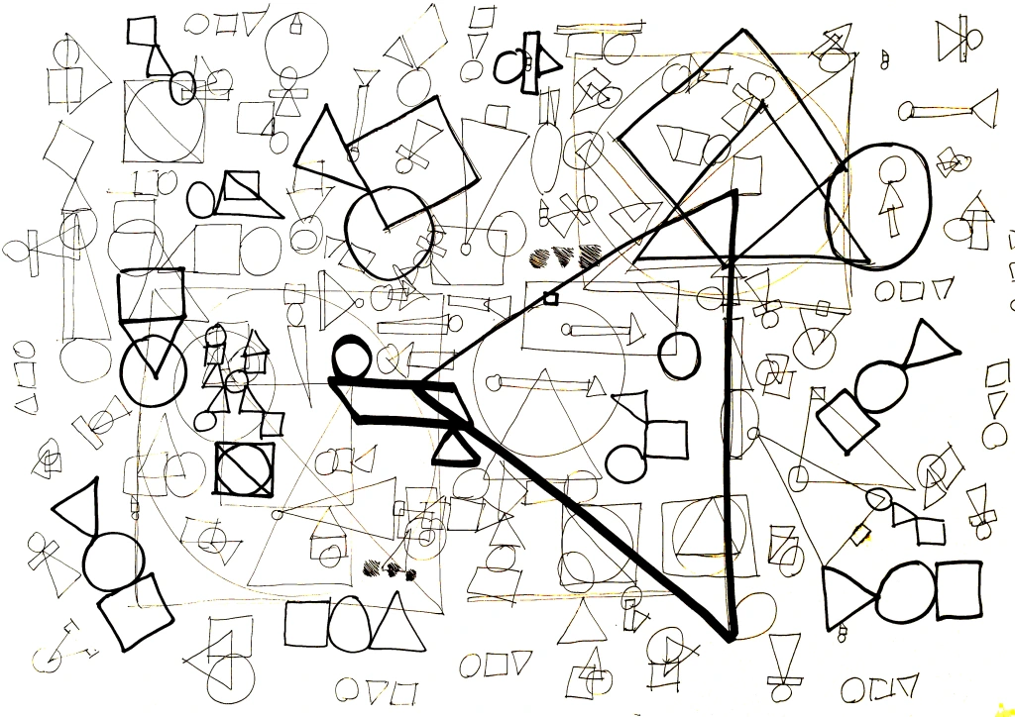

**Menu Functions**



*Before we start I am unsure if you need to recompile or not but when I was transferring files between the Ubuntu VM and my Host I am unable to run the .app (permission denied) in Ubuntu when transferring back to Ubuntu but just in case, command: **g++ -std=c++11 *.cpp -o csci251_a2.app**

**1) Input sensor data**

When users select this option they can input a shape that includes a **Square, Rectangle, Cross** they have to then input whether its a warped shape(**WS**) or not (**NS**) and the number of coordinates (vertices) respectively. For **Circle** you are required to input coords for center and a radius. (assuming the coords are **correct**)

Square, Rectangle - 4 coordinates

Cross - 12 coordinates

Circle - 1 coordinate (center) and radius

After confirming the input pressing **<Enter>** will insert the shape into the array for use later.

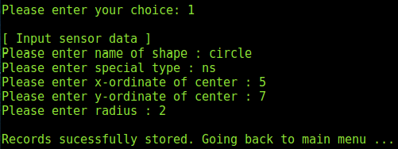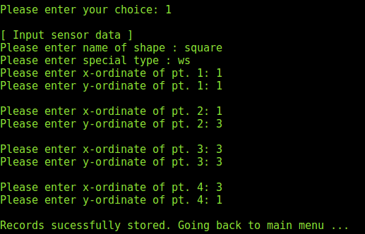

**2) Compute area (for all records)**



When users select this option the program will compute the area for all the shapes that are inserted and it will let you know how many records are updated (depending on the amount of shapes inserted).

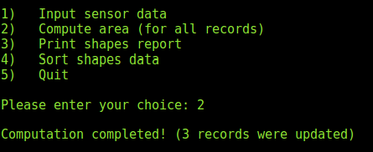

In this example when I pressed 2, I have already inserted a square, rectangle and circle so it would be 3 records.

**3) Print shapes report**

When users select this option the program will print the inputted shape formatted nicely for the user to see based on the order which they inserted. For example, if user keys in circle then square, then circle will show up first then square.

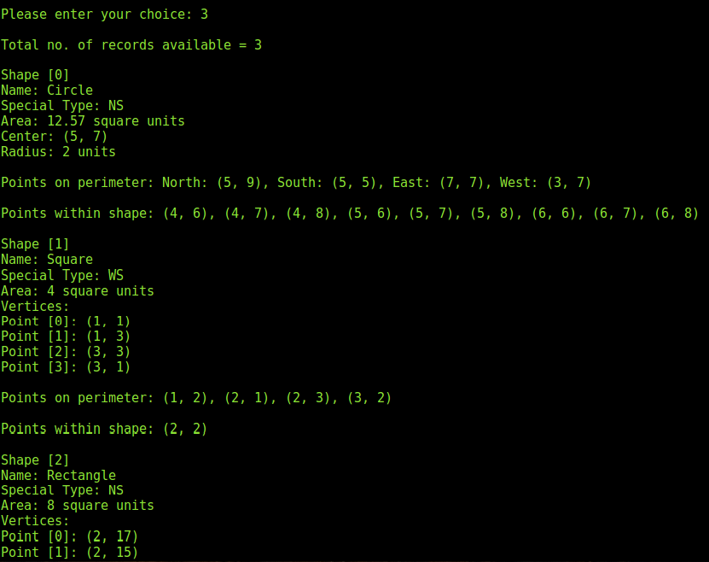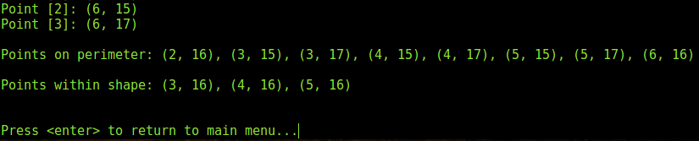

In this example I input Circle, Square then Rectangle.

**4) Sort shape data**



When users select this option the program will sort the shapes in the array according to the user’s desire according to 3 selection which is:

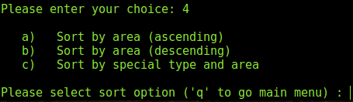

a) Sort by area (ascending)

* Sorts the shapes from small to big (area)

b) Sort by area (descending)

* Sorts the shapes from big to small (area)

c) Sort by special type and area

* Sorts the shape according to WS being first followed by the highest area. For example, WS will be at the top, followed by the highest area in the WS group.

**See below for image example**

**vvvvvvvvvvvvvvvvvvvvvvvvvvvvv**

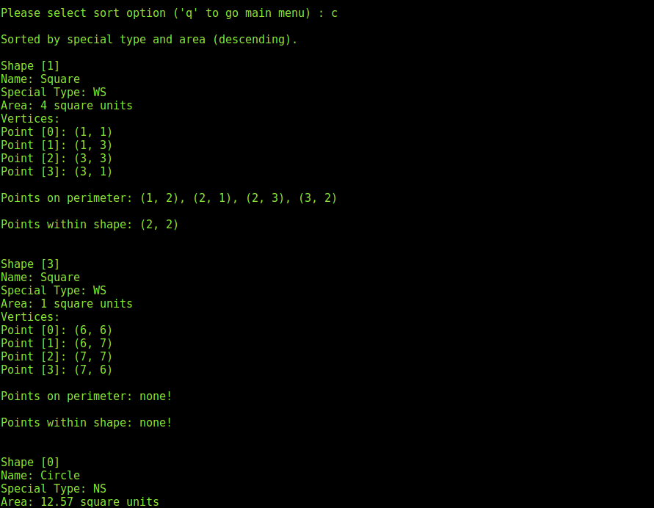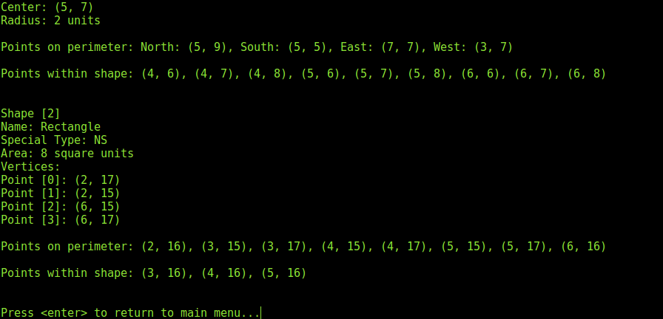

I added a WS square with an area of 1 to show the descending.

Lastly,

q) User can enter **q** to go back to the main menu

**5) Quit**



The last option is **5) Quit** which ends the program at your own discretion and deallocates all the memory slots assigned when the program was opened.

**Reflection**



Difficulty faced:

* Understanding class hierarchy and making sure they get inherited properly
* Cross area implementation (not knowing what to use for calculating the area)
* Cross perimeter (same as area very unsure on how to implement)

Lesson learnt:

* Class hierarchy
* Polymorphism
* Overriding with virtual
* Shoelace method (for calculating Cross)

**End**